Prepared by William Martin Ahlberg VFW Post #1
silverman4969@yahoo.com 087-142-7791

*-*-*-*-*-*-*-*-*-*-*-*-*-*-*-*-*-**-*-*-*-*-*-*-*-*
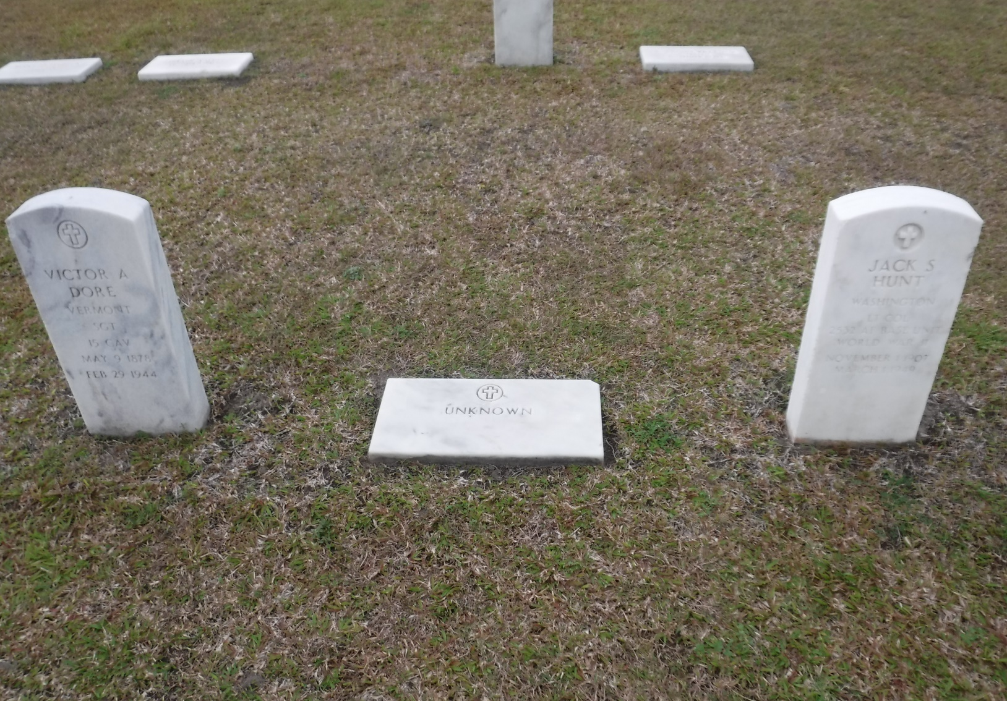
Don’t leave your friends and relatives unprepared.
I suggest you complete the following information as applicable. Print it and give it to a trusted friend or relative. Maintain an electronic copy in a safe place such as with the VFW Service Officer. Check your information correctness every 6 to 12 months and update as required.
Revision July 3, 2018
Revision September 6, 2018
Revision September 10, 2018 Page 9 Navy Federal contact information
Revision September 15, 2018 Page 7 VFW Post 9876 phone and website
Revision September 17, 2018 Page 13 Note about NRA Membership
Revision December 10, 2018 Page 1 Photos
Revision December 10, 2018 Page 3,4,5,6 Photos of your Documents
Revision March 23, 2021 Page 7,8,9,14 Military Service

Important Information

*-*-*-*-*-*-*-*-*-*-*-*-*-*-*-*-*-**-*-*-*-*-*-*-*-*
Table of Contents
Page 1. Revisions
Page 2. Table of Contents
Page 3. Personal information
Page 3. Emergency contacts and Address
Page 3. Next of Kin information
Page 4. Family Information
Page 5. Last Will and Testament Notarized by Thai
Page 6. Power of Attorney Notarized by Thai
Page 7. Military Service and Retirement information
Page 8. DD-214
Page 9. Secondary Retirement information
Page 10. Computers and Social Media information
Page 11 & 12. Banking and Money
Page 13. Insurance
Page 14,15,16 &17. US Embassy information
Page 18, 19. When Someone Dies in Thailand (By Leslie Wright)
Page 20 & 21. When Someone Dies in Thailand (By Sai)
Note: Pages are general in nature and my not accurately reflect the contents due to updates and information pertinent to the individual

Photos Of your Identification

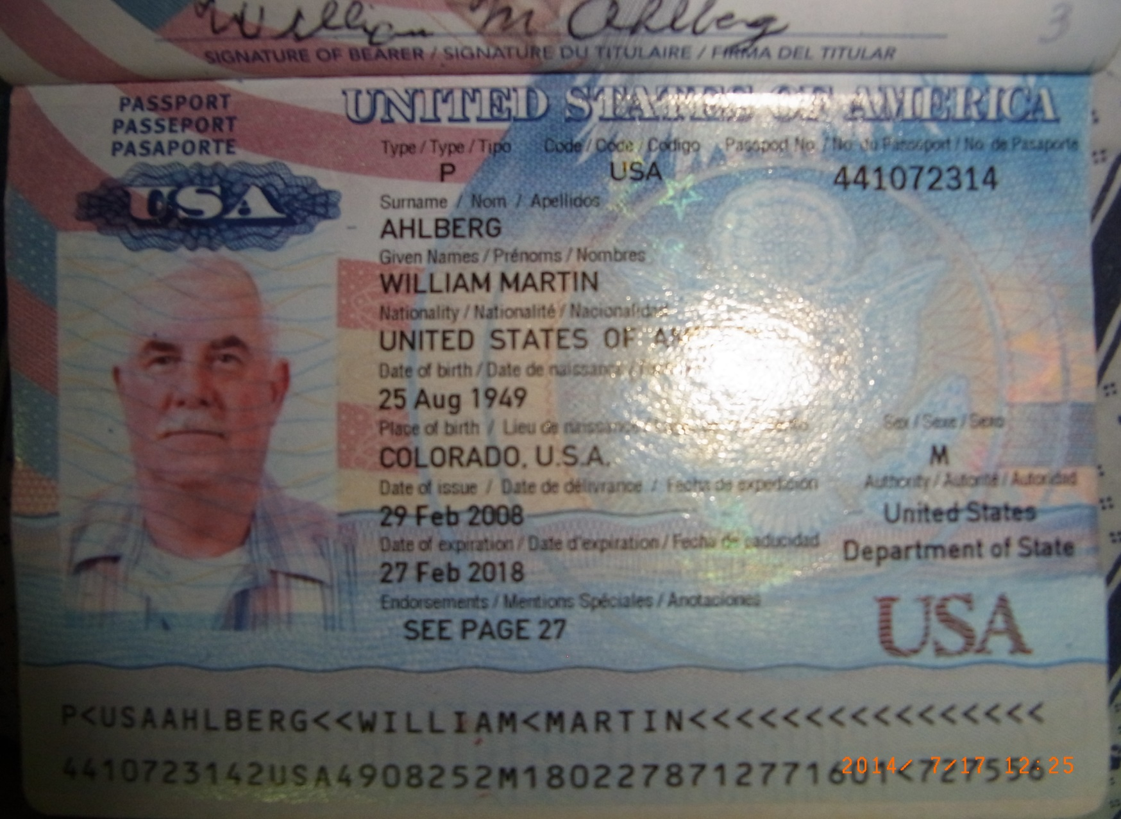

Your Birth Certificate

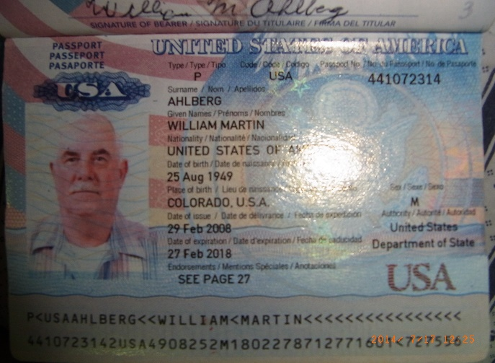

Your Marriage Certificate

Military Service
US Navy I am a Life member of VFW Post #1 in Denver Colorado.
A copy of my military papers (DD-214), Will, Power of Attorney and other information might be available from the service officer at local American Legion or VFW.

Pattaya Post Thomas Oliver Ahlberg Memorial Post TH02
or
Pattaya Post 98196 Office phone 038-423-462 www.vfwpost9876.org
or
Ban Chang Post 12146.

My service information as follows;
John Doe
Service US Navy
Birth August 25, 1909 in somewhere Colorado
Service number B739000 Social Security # 523-68-000
Enlisted in SantaFe New Mexico October 1908 on the delayed enlistment program. Reported to Albuquerque New Mexico Dec 23, 1908 for induction and physical. Fly to SanDiego California for Boot camp on Dec 24, 1908. To Pearl Harbor Hawaii March 1909 for my first assignment.

Service included; USS Maury AGS 00.
US Navel Air station Pensacola, Florida, Fleet services Tug Boat USS Konoka YTM 522.
USNS Chauvenet TAGS- 0032, Navel detachment.
Discharged Treasure Island April, 1904.

Military Retirement information
xxxxxxxxx

*-*-*-*-*-*-*-*-*-*-*-*-*-*-*-*-*-**-*-*-*-*-*-*-*-*

Attach your DD-214 as this page

US Navy
xxxxxxxxx

Photo Of your DD-214

Your Veteran Information

American Legion or VFW Membership card

American Legion Post TH02

Contact in Pattaya William Ahlberg 087-142-7791

VFW Post 9876

Contact in Pattaya William Ahlberg 087-142-7791

VFW Post 121469876

Contact in Pattaya William Ahlberg 087-142-7791

John Doe (Nick Name John)

SSN Birth date Drivers License Passport
523-68-xxxx August 25, 1949 Thailand 57000000 5617533xx
Home 66-38-xxx-xxxx
Skype
E-Mail silverman4969@yahoo.com password animal above my desk
Wildbill_96@hotmail.com
Silverman4969@gmail.com

*-*-*-*-*-*-*-*-*-*-*-*-*-*-*-*-*-**-*-*-*-*-*-*-*-*
Emergency Contacts
Wife Janice Doe (Jane) 086-145-71xx
Step Daughter Janice Doe (Jane 087-942-34xx
Friend Mike Doe 085-390-94xx
Brother Glen Doe 970-209-61xx

*-*-*-*-*-*-*-*-*-*-*-*-*-*-*-*-*-**-*-*-*-*-*-*-*-*
Pattaya Address Neighbor has the key
John Doe
52 / 158 Moo 5 ChockChai Village #9
Nongprue, Banglamong
Pattaya City, Chomburi
Thailand 20150

*-*-*-*-*-*-*-*-*-*-*-*-*-*-*-*-*-**-*-*-*-*-*-*-*-*

USA Address
(Jonathan Doe) (John) 970-209-61xx
John Doe
12345 6900 Road
Somewhere, Colorado 81401

*-*-*-*-*-*-*-*-*-*-*-*-*-*-*-*-*-**-*-*-*-*-*-*-*-*

Wife’s Information
Jane Doe 086-145-71xx

ID Card Birth date Drivers License Passport
3200600000000 October 31, 1900 49000000 AA46756xx

Address
50 / 1 Moo 5 Tombone, NongKhayat
Amphur Bangkok
Chomburi Thailand 20140

*-*-*-*-*-*-*-*-*-*-*-*-*-*-*-*-*-**-*-*-*-*-*-*-*-*

Step Daughter’s Information
Jane Doe (Jany) 087-942-34xx

ID Card Birth date Drivers License Passport
1102700000000 November 7, 1900 xx Z386000

Address
000 / 000 Hello Village Moo 9
Tombu, Bangsaothong
Samutprakarn, Thailand 10570

*-*-*-*-*-*-*-*-*-*-*-*-*-*-*-*-*-**-*-*-*-*-*-*-*-*

Grand Daughters Information
Jane Doe (Jany) 087-942-34xx

ID Card Birth date Drivers License Passport
1209703700000 December 8, 2007 None None

Address
Chayanutphat Wongthumma
00 / 10 Moo 5 Tombul, NongKhayat
Amphour, Bangkok
Chomburi, Thailand 20140

Grand Daughters Father’s Information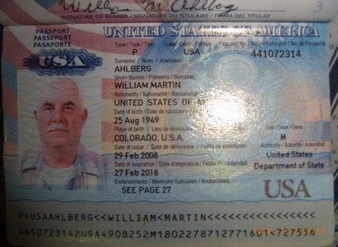

Name is (John)

ID Card Birth date Drivers License Passport
1-9000-00000-64-1 None ?
Age 33 as of Dec 8, 2017
Address as of Dec 8, 2017 Age 33 and July 3,2018
Tanasit Lumphet
000 / 100 Bangkok Village Moo 9
T. Bangsaothong A. Bangsathong
Bangkok, Thailand 10570

*-*-*-*-*-*-*-*-*-*-*-*-*-*-*-*-*-**-*-*-*-*-*-*-*-*
Last will and Testament July 4, 2018
I Jonathan Augustus Doe being of sound mind and body hereby beguine all of my worldly possessions, all moneys and Bank accounts, to my dear and devoted wife Jenny Marie Doe.

In the event Jenny Marie Doe has also passed, all moneys and Bank accounts, to my step daughter Jenny Marie Doe.

In the event Jenny Marie Doe has also passed, all moneys and Bank accounts, to my step daughter Jenny Marie Doe. Assets will remain in escrow and will not be available to her until her 25th birthday.

I leave nothing but good luck to my adopted step son Jenny Marie Doe and the same to my son Jenny Marie Doe. Both of whom have not communicated with me since August 1998.

*-*-*-*-*-*-*-*-*-*-*-*-*-*-*-*-*-**-*-*-*-*-*-*-*-*
Special thanks to my very good friend of many years. Jenny Marie Doe you are the brother I didn’t have.
Friends Photo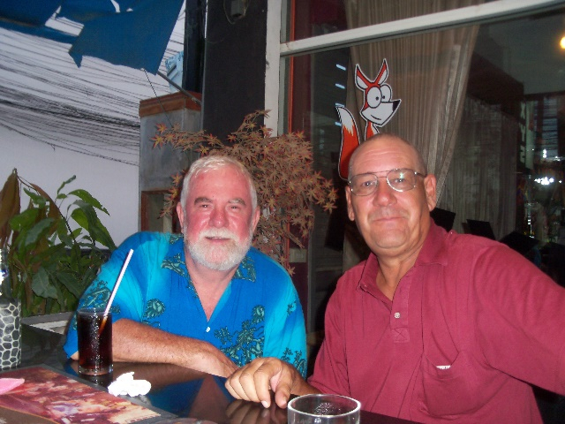
- *-*-*-*-*-*-*-*-*-*-*-*-*-*-*-*-*-**-*-*-*-*-*-*-*-* No life sustaining support systems are to be used to prolong my life.
- Note If you are an NRA member you might have free repatriation service
- Cremate my remains and disposition of my ashes to my Thai family.

*-*-*-*-*-*-*-*-*-*-*-*-*-*-*-*-*-**-*-*-*-*-*-*-*-*
General Power of Attorney
For
Jonathan Martin Doe
Know all persons that I John Doe SS# xxx-xx-xxxx Born on 08-25-49 in somewhere Colorado and now residing in the Kingdom of Thailand at 00 / 000 ChockChai Village 10, Neurnplubwan, City of Pattaya, do convey and assign all legal rights of authority to the following persons upon my death or incapacitation.
Jenny Marie Doe (Wife) Thai ID # 00000000000000000000000000
30 / 1 Moo 5 Tombone, NongKhayat
Amphur Phanat Nacomb
Chomburi Thailand 20140
Or
Jenny Marie Doe (Step Daughter) Thai ID # 00000000000000
222 / 107 Villagio Village Moo 9
Tombu, Bangsaothong
Samutprakarn, Thailand 10570

For the following
- All matters including but not limited to land, autos, personal property, banking accounts and personal effects.
- Instructions regarding hospitalization or bodily remains (cremation).
- No life sustaining support systems are to be used to prolong my life.
- Organ donation is encouraged.
John Doe Date September 06, 2018

Notary signature / /2018 Seal Here

*-*-*-*-*-*-*-*-*-*-*-*-*-*-*-*-*-**-*-*-*-*-*-*-*-*

Secondary Retirement Information

Civil service
xxxxxxx

Career Company

Photo Of your Company ID Card

xxxxxxxx

Social Security Provide your Social Security card, Number, Deposit amount and date

Photo Of your SS Card

xxxxxxx

Military
xxxxxxxx

xxxxxxx

Other
xxxxxxxx

Media Information

*-*-*-*-*-*-*-*-*-*-*-*-*-*-*-*-*-**-*-*-*-*-*-*-*-*

Computers

Pattaya Computer password None
Farm Computer password None
Laptop password 00000
***********************************************************************
E-mail
Jenny Marie Doe
silverman0000@yahoo.com Password xxxxxxxxxxxx
Secret question answers 1. xxxxx 2. xxxx
silverman0000@gmail.com Password xxxxx
wildbill0000@hotmail.com Password xxxxxxx
***********************************************************************
Social Networks
Jenny Marie Doe
Facebook Password xxxxxxx
***********************************************************************
Note
Facebook and maybe others have a service where your death can be noted and it might be a good place for a friend or loved one to notify your followers about your death.

Banking and Money Information
***********************************************************************

Navy Federal Credit Union
Phone 701-7948000 701-818-0000
In person access by calling us toll-free anytime at 1-888-842-NFCU (6328) or collect at 1-703-255-8837
John’s account # 123456789xxxxxxxxxx
Login Access # Jonathan Augustus Doe Password xxxxxxxxxx
Secret question answers xx
ATM card 123456789xxxxxxxxxx Password xxxx
Debit card 123456789xxxxxxxxxx Password xxxxx
2nd account # 123456789xxxxxxxxxx Password xxxxxxxxx
ATM card 123456789xxxxxxxxxx Password 7200
Debit card 123456789xxxxxxxxxx Password 72000
***********************************************************************
White Sands Federal Credit Union
Phone xxx-575-4500
Account # 1123456789xxxxxxxxxx Password xxxxx
ATM Password xxxx
***********************************************************************
Bank of Bangkok
Phone xxx-
Internet access WWW.BANGKOKBANK.COM
User ID 123456789xxxxxxxxxx Password xxxx
Swift Code 026008691

John’s Savings account # 123456789xxxxxxxxxx
Password 72xx
ATM 123456789xxxxxxxxxx ATM Password xxxx

John’s & Jane’s Joint savings account # 123456789xxxxxxxxxx
Password 72xx Used for automatic bill paying
ATM 123456789xxxxxxxxxx ATM Password 72xx
***********************************************************************

Kasakorn Bank
Phone 02-888-8888
23/17 M6 Sumkumvit Road Naklue Thailand 20150
Jane’s Savings account # 123456789xxxxxxxxxx Password xxxx
ATM Password 99xx
***********************************************************************
Krungsi Bank (Yellow Bank)
Phone 02xcxxxxxxxxx
xxxx M6 Sumxx Road Bang Bo Thailand xxx
Jane’s Savings account # 123456789xxxxxxxxxx Password xxxx
ATM 123456789xxxxxxxxxx
Password 33xxx
***********************************************************************

*-*-*-*-*-*-*-*-*-*-*-*-*-*-*-*-*-**-*-*-*-*-*-*-*-*

Insurance Information

Medical
Tri care
NRA members repatriation from anywhere in the world

Life
VFW members accidental Death $1000

Burial
xxxxxxxx

Photo Of your Insurance Card

*-*-*-*-*-*-*-*-*-*-*-*-*-*-*-*-*-**-*-*-*-*-*-*-*-*

US Embassy Information

Contact US Embassy
American Citizen Services (ACS)
U.S. Embassy Bangkok
95 Wireless Road
Bangkok 10330 THAILAND
Telephone from USA: 011-66-2-205-4049
Telephone from Thailand: 02-205-4049
Fax: +66-2-205-4103
E-mail: ACSBKK@state.gov

Useful Emergency Numbers
Services
Tourist Police
Police (General Emergency Call)
Ambulance and Rescue
Fire
National Disaster Warning Centre

Phone: +66-53-107-700
Fax: +66-53-252-633
Email: acschn@state.gov

Death of a U.S. Citizen
Home | U.S. Citizen Services | Death of a U.S. Citizen
The U.S. Embassy is ready to assist family and friends in the event of the death of a U.S. citizen in Thailand. The American Citizen Services unit can:
- Confirm the death, identity, and U.S. citizenship of the deceased.
- Notify the next-of-kin.
- Provide information about the disposition of the remains and personal effects of the deceased.
- Prepare documents for the disposition of the remains in accordance with instructions from the next-of-kin or legal representative.
- Provide guidance on forwarding funds to cover costs.
- Serve as provisional conservator of the estate if there is no legal representative in the country.
- Send the Consular Report of Death Abroad to the next-of-kin or legal representative for use in settling estate matters in the United States.

Notification of Next-of-Kin
Thai authorities normally notify the U.S. Embassy when a U.S. citizen dies in Thailand. The American Citizen Services unit contacts the next-of-kin of the deceased as soon as possible. Next-of-kin is established in the following order:
- legal spouse
- if no spouse, then all children
- if no children, then all parents
- if no parents, then all siblings
- if no siblings, then all grandparents.
It is the responsibility of the next-of-kin to:
- If the deceased had a Last Will & Testament, send it to American Citizen Services at U.S. Embassy Bangkok by email or fax.
- If the deceased did not have a Last Will & Testament, send notarized Affidavits of Next-of-Kin (PDF 185 KB) to American Citizen Services at U.S. Embassy Bangkok by email or fax. Next-of-kin in Thailand may have affidavits notarized at the U.S. Embassy American Citizen Services unit free of charge. Email: ACSBKK@state.gov
Fax: +66-2-205-4103
- Make arrangements for the disposition of remains and personal effects of the deceased, often with the assistance of a Thai funeral home.
- Pay for mortuary and related expenses.

Affidavit of Next-of-Kin and Letter of Instruction
The Thai forensic institute or hospital may require a letter of instruction from the U.S. Embassy to release remains of a U.S. citizen into the custody of the next-of-kin or designated representative. The American Citizen Services unit can produce a letter of instruction upon receipt of explicit guidance in the form of a legal will or a signed and notarized Affidavit of Next-of-Kin (PDF 185 KB).

Disposition and Repatriation of Remains
When a U.S. Citizen dies in Thailand, the body is usually preserved until instructions are received from the next-of-kin regarding the disposition of remains. There are normally two options:
- Cremation in Thailand and interment or scattering of ashes in Thailand, the United States or other location
- Embalming in Thailand and air shipment to the United States or other location for burial
Please note that embalming and mortuary services in Thailand may not meet U.S. standards. Families are advised to consult with a funeral director in the United States about the advisability of viewing remains and conducting an open-casket funeral.
More information including approximate cost of services can be found in the Disposition of Remains Report–Thailand (PDF 232 KB).

Funeral Homes in Thailand
DISCLAIMER: The U.S. Embassy Bangkok assumes no responsibility or liability for the professional ability or reputation of, or the quality of services provided by, the following persons or firms. Names are listed alphabetically, and the order in which they appear has no other significance. Professional credentials and areas of expertise are provided directly by the funeral directors, morticians and other service providers.
AsiaOne International by Teck Hong Funeral (THF)
No.7, THF Building, Chan Road Soi 46
Wat Phrayakrai, Bangkholaem
Bangkok 10120 THAILAND
Phone: +66-2-675-0501; +66-2-675-0502
Mobile: +66-81-854-3165 (Mr. Hiran)
Mobile:+66-81-845-7592 (Ms. Jessica)
Fax. +66-2-675-2227
info@asiaone-thf.com
http://www.asiaone-thf.com/
John Allison Monkhouse Co., Ltd (Thailand)
Suite 302, S16 Building, 256/9 Sukumvit Soi 16
Klongtoey
Bangkok 10110 THAILAND
Phone: +66-2-261-7929; +66-2-382-5345
Mobile: +66-89-215-7799 (Ms. Pim Karnasuta)
Fax: +66-2-261-7939 (Mrs. Duangdao Micallef)
pim@allisonmonkhouse.com
http://www.funeralrepatriation.com/
Siam Funeral Co., Ltd
30/21 Village No. 6
Klongsi, Klongluang
Pathumthani 12120 THAILAND
Phone: +66-2-902-7907
Mobile: +66-86-777-0214
Fax: +66-2-902-7906
siamfuneral@gmail.com
http://www.siamfuneral.com/

Financial Arrangements
The next-of-kin or legal representative of the deceased is responsible for paying all funeral home expenses and costs associated with shipping the remains and any personal effects. In most cases, the next-of-kin is able to make payment arrangements directly with a funeral home.
Funeral Homes in Thailand–Price Lists (PDF 900 KB)

Autopsies
In order to determine the cause of death, the medical examiner on the scene may recommend an autopsy when a U.S. citizen dies outside of a hospital setting. Autopsies are normally performed free of charge by the Forensic Institute at the Police General Hospital in Bangkok or by another forensic institute within 24 hours of receiving the remains. Thai autopsy reports take at least 45 business days to produce and may fall short of the standard expected in the United States.
Autopsies are not typically performed on U.S. citizens who die in hospitals, except at the request and expense of the next-of-kin. Hospitals are normally able to provide a cause of death, which is required for issuance of a Thai death certificate.

Timing
Next-of-kin are advised to be flexible regarding dates for funeral ceremonies in the United States. It takes time to perform an autopsy, embalm or cremate the body, prepare remains for shipment, and produce the necessary documents. Please allow 10 or more days from the date of death for remains to arrive in the United States.

Return of Personal Effects
Funeral homes in Thailand can assist with itemizing and returning personal effects of the deceased to the next-of-kin or designated representative.

Consular Report of Death of an American Citizen Abroad
The U.S. Embassy issues an administrative document called a Consular Report of Death Abroad that provides essential facts about the death, disposition of remains, and custody of the personal estate of a deceased U.S. citizen. The Consular Report of Death Abroad is based on the Thai death certificate and may be used in legal proceedings in the United States as proof of death.
In order to issue a Consular Report of Death Abroad, the American Citizen Services unit must first receive all of the following:
- The original Thai death certificate
- An English translation of the Thai death certificate, certified by a professional translator (Note: Most funeral homes in Thailand include the cost of translation in their service packages.)
- The original U.S. passport of the deceased
The American Citizen Services unit will send the following documents to the next-of-kin:
- Consular Report of Death of an American Citizen Abroad (A maximum of 20 copies are provided free-of-charge; additional certified copies may be ordered from the Department of State for a fee.)
- The original Thai death certificate and English translation
- The deceased’s canceled U.S. passport
For more information, please refer to the Department of State website.

Contact Us
American Citizen Services (ACS)
U.S. Embassy Bangkok
95 Wireless Road
Bangkok 10330 THAILAND
Telephone from USA: 011-66-2-205-4049
Telephone from Thailand: 02-205-4049
Fax: +66-2-205-4103
E-mail: ACSBKK@state.gov

*-*-*-*-*-*-*-*-*-*-*-*-*-*-*-*-*-**-*-*-*-*-*-*-*-*

FYI--- Thai Information
Family Money: In case you’re not immortal ... and living in Thailand By Leslie Wright, Managing director of Westminster Portfolio Services (Thailand) Ltd. A Last Will & Testament may be in any one of four forms, with varying degrees of safety from challenge. First, what is known as a ‘holographic will’ which means you wrote it out by hand and you make corrections and verify them yourself. Second: a Will made with a lawyer. Corrections on the first two types of Wills, if evident, are points of attack by an opposing lawyer. Third: a Public Will, which is the strongest Will available in Thailand. The form for this type of Will is in Thai, which needs to be filled out, and cannot be attacked, and is available at the District House at Banglamung, Amphur* office, and at Pattaya City Hall, Amphur* Office and may cost 100 baht. (*Amphur is the same as the Council Office in the UK, or City or County Clerk in the USA.) The fourth is none: you die intestate and your goods are distributed by the state according to certain rules. Thai rules It is worth remembering that there is no second language in Thailand, so if there is a question between an English translation and a Thai translation, the Thai wins. Any language is accepted, but if translated into Thai, the Thai version prevails. Bear in mind that only a will written in Thai is technically admissible in a Thai court: the one in English is for your convenience and information only. Westerners are used to the concept of naming their own Executor in their Will. In Thailand it is technically the court who appoints your Executor: in your Will you name a “Personal Representative” (who may be a relative, friend or your lawyer) who is usually accepted by the court and appointed your Executor. Your Executor is then charged with ensuring any taxes due are paid, and the assets listed in your Will are distributed according to your wishes – even to someone on the other side of the world! The Executor may charge the estate a reasonable amount or fee for time spent and for expenses incurred carrying out these duties; but the testator will usually have set a reasonable limit on the amount his Personal Representative may charge in toto. While you can include property and other assets in another Country in a Will made in Thailand, and this Will may be accepted in your own country, the safest method is to have a Will in each country covering your assets in each – and specifying that this Will covers only those assets held in, for instance, the United Kingdom. Another Will is similarly drawn up, specifying that this Will covers only those assets held in Thailand. A third may cover Australia – and so on. This may sound onerous, but is also sound tax planning. Life Partnerships There is no direct law on live-in partners: the closest law is business partnership law, and has mostly to do with moveable property. If you put property in your partner’s name, and you want it back or part of it, it is very difficult. The legal age in Thailand is variable depending on circumstances from 18 through 20. If your partner is 21 or more, she or he is past the age of requiring consent. But children 15 years of age and younger engaged in sexual acts are considered by statute to have been raped regardless of any consent given. At ages 16, 17 and 18, you can be sued by the parents. If you want to separate from a partner, you will usually get what is yours and she will get what is hers. It is therefore wise to keep an inventory of the things you buy for her, things she buys for you, and things you buy jointly. Houses and property, in your Thai partner’s name, are theirs regardless of who paid for the property. Use loan and rent agreements to retain control of the property, or form a company. Having children in an unmarried relationship is evidence of a long-term relationship: it is therefore a partnership, and partnership law governs. Thai law is based on Community Property, so if you get married, what you or she had before the marriage are your separate properties, whereas what you acquired or earned after the marriage is joint property, and divided equally in the event of divorce. Pre-nuptial Agreements are legal in Thailand and will be upheld by the Court. Don’t forget that your Thai will should list (as an Appendix) all your assets in Thailand, including bank accounts (with branch address and account numbers); vehicles (if they’re in your own name) including registration number, chassis & engine numbers; condominiums and shares in companies owning property; jewelry and personal possessions, including paintings and objects d’art. It saves squabbling if you specify who inherits each item or the proceeds of liquidation of that asset.

*-*-*-*-*-*-*-*-*-*-*-*-*-*-*-*-*-**-*-*-*-*-*-*-*-*

What How to Do All Things When Someone Dead Dies in Thailand (From the Thai Internet By Jane)

Case 1: Death in the a Hospital
1. After the patient dies wait for 2 hours to make sure that person really dead, the physician will issue a death certificate to relative(s). While waiting for a paper must call the Embassy tell them name, surname and passport number of dead deceased person then the Embassy will issue a death certificate and send a paper back via email or fax it depends on conversation with the officer.
2. After you have received a death certificate from the physician then bring a relative ID card, a ID card or a passport of the dead deceased person and a the house registration (if this book has a name of the death deceased person) with a death certificate for submission to the registrar at the district or local government office within 24 hours after death for issue a death certificate.
3. In case if the dead body deceased is a foreigner have to one will have to wait until the hospital receive a death certificate is issued from the Embassy then the relative(s) can move a dead body can be moved to the temple.

Case 2: Natural Death inside the house (Death outside the hospital)
The lists below are examples explain which kind of dead is included in this case.
1. Die in your own house
2. Die in relative(s) house
3. Die in factories or at work
The relative(s) or the person who assign responsible to inform the dead body Someone must have to go to the police station and report the information on the deceased person then the policeman will issue an official memorandum paper. Bring all documents must be submitted to the local government office within 24 hours count from that person dead or someone see the body.

- If the deceased is in the District area one will have to inform to a Village headman then the Village headman will issue a death certificate. The relative(s) of the deceased dead person have to bring a relative ID card, a ID card or a passport of the deceased dead person and a house registration (if this book has the a name of the deceased death person) with a death certificate for submission to the registrar at the district government office for issue a death certificate.
- If the deceased dead person die’s in the Municipal area one will have inform the to Municipal office and that office will issue a death certificate. The relative(s) of the dead person have to bring a relative ID card, a ID card or a passport of the deceased dead person and a house registration (if this book has a name of the deceased death person) with a death certificate for submit to the registrar at the district government office for issue a death certificate.

Case 3: Death outside the house
The lists below are examples explain which kind of dead is included in this case.
1. Pavilion waiting for bus
2. In a car
3. Rice field
4. Forest etc.
The relative(s) or the person who assign responsible to inform the dead body Someone must have to go to the police station and report the information on the deceased person then the policeman will issue an official memorandum paper. Bring all documents must be submitted to the local government office within 24 hours count from that person dead or someone see the body.
For unnatural dead whether inside or outside the house such as suicide, being killed, accidently falling from high place, snake bite etc. Call the police. The police will move the body for to autopsy (because that is a part of investigation,) before filling documents with the registrar officer at district government office.

Step at district government office
After submitted all documents have been submitted to the registrar officer at district government office, the office will issue a death certificate and the officer will stamp a word “Dead” in red color on a house registration to indicate so this all process have been completed are done.

Step in temple
1. Before the dead deceased body can be moved to the temple, someone will first of all the relative(s) have to contact the temple and arrange for an appointment on what day you will move the dead body and reserve the time date to keep the body before cremation such as reserve one day, 3 days, 7 days or as many days you want depends on money.
2. The temple will prepare many things for funeral such as
- Funeral wood flower
- Fresh flower decorations for the decorate front of coffin
- Special incense
- Candle
- Red thread
- Lantern
- White envelopeasds envelopes
3. Things we have to buy not provided by the temple
- Coffin
- Food

Death certificate from government is a paper to guarantee that this person really die.
Death certificate from Embassy, the Embassy will keep real copy and the relative(s) of death person will received only copy document.
This is the reason why Thai people don’t like to write their name in red color because it’s similar to a word “Dead”

